Practice SAC 3 – Solutions

Question 1:
Possible graphical displays include (make sure you know how to do this on your CAS)
- Parallel Box Plots
- Parallel Dot Plot
- Parallel Histograms
- Back to back Stem and Leaf

- Parallel Box Plots
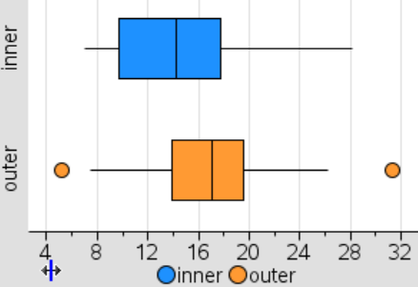
d. Back-to-Back Stem and Leaf
Key: 5 | 1 = 5.1
Inner | Stem | Outer
 | 5 | 2
 | 6
0, 0 | 7 | 5
 | 8
5, 5, 0 | 9
5, 5, 0 | 10
 | 11 | 0, 3
 | 12
5 | 13 | 6
5, 0 | 14 | 3
0 | 15 | 2, 5
0, 0 | 16 | 4, 5
0 | 17 | 1, 1, 9
5 | 18 | 7, 9
 | 19 | 4, 7
 | 20
 | 21
 | 22
 | 23
5, 5 | 24 | 6
 | 25
5 | 26 | 1, 2
 | 27
2 | 28
 | 29
 | 30
 | 31 | 3

- Dot Plots
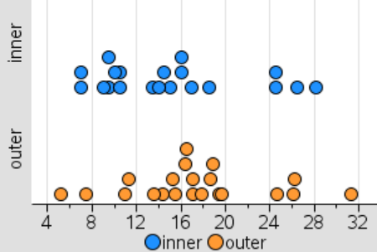

- Histogram
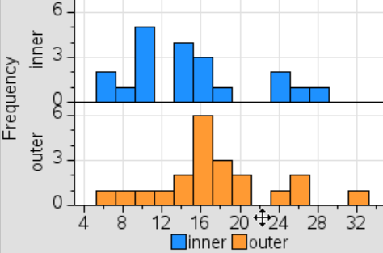

An association exists between the type of suburb (inner or outer) and the population. The Parallel box plots show that the median population is 17.1 thousand in Outer suburbs, whilst it is 14.25 thousand in Inner suburbs. The range of populations size is 26.1 thousand in Outer Suburbs and 21.2 thousand for Inner suburbs.

Always clearly start with a clear sentence that states if an association exists between the variables. When stating that an association exists you MUST use data in your explanation, begin with quoting the medians and then consider IQR and range.

Question 2:

- Use CAS to calculate the Mean and Standard Deviation
Menu – Stats – Stat Calculations – One Var Stats

Mean = 15.06 Standard Deviation = 6.48

- Normal Distribution Curve

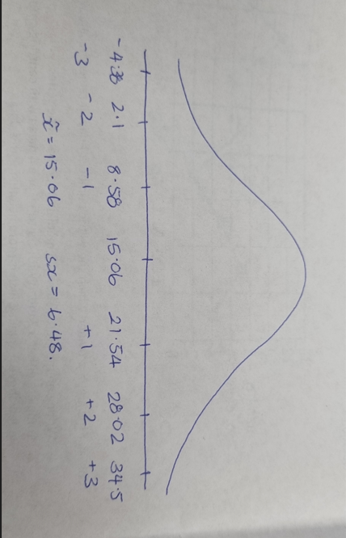

- Z Score = $\frac{Actual Score- mean}{standard deviation}$

= $\frac{11-15.06}{6.48}$ = - 0.63

- Solve ( -1.6 = $\frac{x-15.06}{6.48}$ , x ) = 4.69
The population of an inner suburb has a z score of -1.6 which indicates the population lies below the mean in the bottom 16%. The actual population of the inner suburb is 4.69 (4690 people).

Can you identify where a z score of -1.6 is? If you can identify where the z score is and see that 2.1 and 8.58 are labelled at z = -2 and -1, you will be aware that the answer needs to fit in between these values.

Question 3:

- Make sure you draw and label a graph on your SAC
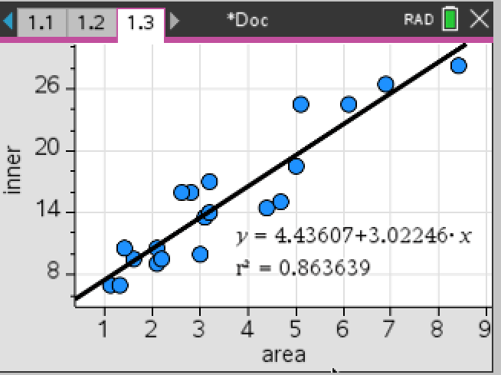

- In this analysis, the Population is the RV and Area is the EV.
The line “population ….. can be predicted from area” – we know that RV is predicted from EV.

- The equation of the least squares regression line is:
Population of inner suburb= 4.43607 + 3.02246 x Area
Make sure you use the correct variable, using x and y is NOT acceptable. Also be careful with your rounding, rounding too much will have a very big effect on predictions later on.
ON THE SAC SKETCH THE SCATTERPLOT AND THE LSR, label the axis.

- There are no outliers.

- From the scatterplot, we see there is a Strong, positive, linear relationship between the area and population, with r = 0.9293.

- The slope of the regression line predicts that, on average, the Population increases by 3.022 thousand for every increase of 1km² of Area.

- When the Area is 0km² the Population is 4.43 thousand. (A good example of when the Intercept is not a viable interpretation! Notice that 0km² is extrapolation – unreliable data.)

- r² = 0.929322² = 0.863639 = 86.36%
The coefficient of determination indicates that, on average, 86.36% of the variation in the Population can be explained by the variation in Area.
Do not round the % to a whole number – keep it to 2dp unless otherwise stated

- The residual plot shows no clear pattern, supporting the assumption that the relationship between the Population and the area is linear.
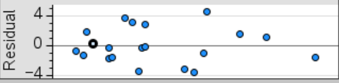
- Actual = 14.5 (this value is taken from the table of data, when Area = 4.4, Population = 14.5))
Predicted = Population of inner suburb= 4.43607 + 3.02246 x Area = 4.43607 + 3.02246 x 4.4 = 17.7349
Residual = Actual – Predicted = 14.5 – 17.73 = - 3.23
Its important to clearly highlight what you are finding, do not expect the assessor to ‘just know’ what you are talking about! Show your working out as it is shown above!
- Population of inner suburb= 4.43607 + 3.02246 x Area = 4.43607 + 3.02246 x 9.1 = 31.94
This shows that the prediction is again an overestimation but as the area considered is outside of the range for area this prediction is extrapolation and therefore unreliable.
Question 4:
The scatterplot and residual plot show that there is a nonlinear pattern to the data and that making a linear regression analysis is not possible unless the data is linearised using a transformation.
Transformations that could be used are 1/area , log ₁₀ (area) or population²

a = 14.359
b= 0.079031
r= 0.58105
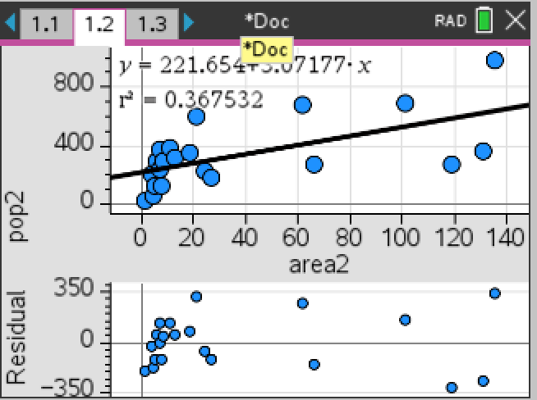
r²= 0.3376

 | Transformed LSR Equation | r | r² | Residual Plot
Log (area) | Population = 7.7277 + 7.7015 x log(area) | 0.69677 | 0.485488 | See below
Population² | Population² = 221.654 + 3.07177 x area | 0.60624 | 0.367532 | See below

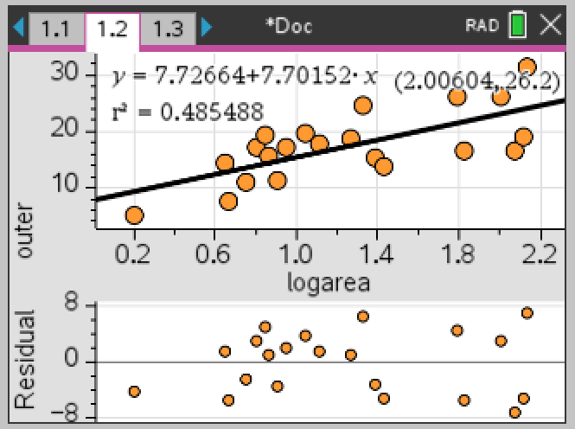

Log(Area)
The residual plot now looks random and the scatterplot looks approximately linear.
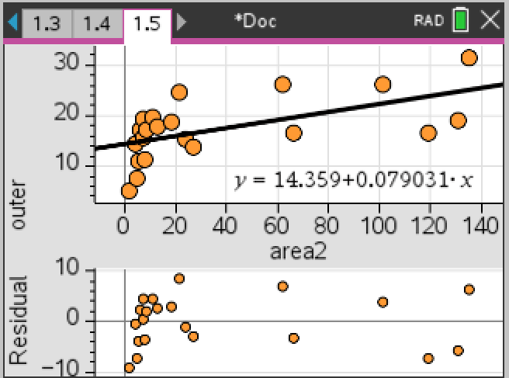

Population²
The residual plot and the scatterplot both still shows nonlinear patterns.

Seeing the resulting r and r² and the new scatterplot and residual plot we can see that using the log₁₀ (area) is the better way to linearise the data set.

- Population = 7.7277 + 7.7015 x log(area) = 7.7277 + 7.7015 x log(90) = 22.778
Population = 22.778 thousand when Area = 90 km²

Question 5:

- 3 Median Smoothing
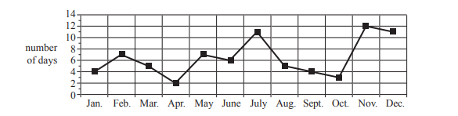

- 2 mean smoothing with centring
- 4 mean smoothing with centring
Jan | 4 |  | -
 |  | -
Feb | 7 |  | -
 |  | $\frac{4+ 7+5+2}{4}$ = 4.5
Mar | 5 |  | $\frac{4.5+5.25}{2}$ = 4.875
 |  | $\frac{7+5+2+7}{4}$ = 5.25
Apr | 2 |  | $\frac{5.25+5}{2}$ = 5.125
 |  | $\frac{5+2+7+6}{4}$ = 5
May | 7 |  | $\frac{5+6.5}{2}$ = 5.75
 |  | $\frac{2+7+6+11}{4}$ = 6.5
June | 6 |  | $\frac{6.5+7.25}{2}$ = 6.875
 |  | $\frac{7+6+11+5}{4}$ = 7.25
July | 11 |  | $\frac{7.25+6.5}{2}$ = 6.875
 |  | $\frac{6+11+5+4}{4}$ = 6.5
Aug | 5 |  | $\frac{6.5+5.75}{2}$ = 6.125
 |  | $\frac{11+5+4+3}{4}$ = 5.75
Sept | 4 |  | $\frac{5.75+6}{2}$ = 5.875
 |  | $\frac{5+4+3+12}{4}$ = 6
Oct | 3 |  | $\frac{6+7.5}{2}$ = 6.75
 |  | $\frac{4+3+12+11}{4}$ = 7.5
Nov | 12 |  | -
Dec | 11 |  | -

Jan | 4 |  | -
 |  | $\frac{4+7}{2}$ = 5.5
Feb | 7 |  | $\frac{5.5+6}{2}$ = 5.75
 |  | $\frac{7+5}{2}$ = 6
Mar | 5 |  | $\frac{6+3.5}{2}$ = 4.75
 |  | $\frac{5+2}{2}$ = 3.5
Apr | 2 |  | $\frac{3.5+4.5}{2}$ = 4
 |  | $\frac{2+7}{2}$ = 4.5
May | 7 |  | $\frac{4.5+6.5}{2}$ = 5.5
 |  | $\frac{7+6}{2}$ = 6.5
June | 6 |  | $\frac{6.5+8.5}{2}$ = 7.5
 |  | $\frac{6+11}{2}$ = 8.5
July | 11 |  | $\frac{8.5+8}{2}$ = 8.25
 |  | $\frac{11+5}{2}$ = 8
Aug | 5 |  | $\frac{8+4.5}{2}$ = 6.25
 |  | $\frac{5+4}{2}$ = 4.5
Sept | 4 |  | $\frac{4.5+3.5}{2}$ = 4
 |  | $\frac{4+3}{2}$ = 3.5
Oct | 3 |  | $\frac{3.5+7.5}{2}$ = 5.5
 |  | $\frac{3+12}{2}$ = 7.5
Nov | 12 |  | $\frac{7.5+11.5}{2}$ = 9.5
 |  | $\frac{12+11}{2}$ = 11.5
Dec | 11 |  | -

